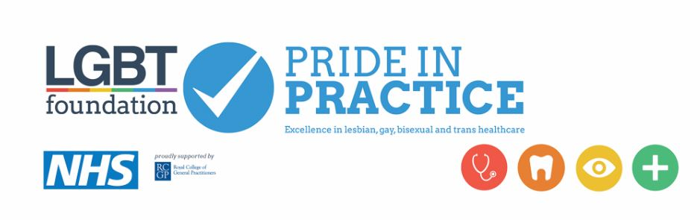
Common questions/concerns when collecting sexual orientation, gender identity and trans status on registration forms.

What do we do with this information?
We use this information provide the best standard of healthcare possible, tailoring our services, signposting and conversations to your specific healthcare needs. We can also use the data collected to make sure the services we provide accurately reflect patients accessing our services. We can also use data collected to identify the prevalence rate of conditions within particular groups.

Who will it be shared with?
The practice is bound by strict confidentiality and the General Data Protection Regulations 2018 (GDPR). This means we will only share your information if consent is provided or if necessary for your healthcare e.g. referrals to other clinical services. Where requested, information will be shared with lawyers, for insurance forms etc.

For trans patients we adhere to the Gender Recognition Act 2004 and will not disclose a patient’s transgender history to a third party without written consent to do so.

Why do we collect it?
Under the Equality Act 2010, we have a duty of care to pay due regard to patients with protected characteristics. For this reason we collect a variety of demographic information in order to tailor the service and support you receive from us. Sexual orientation and trans status monitoring are one of many pieces of information we collect from our patients.
If you are not comfortable providing this information, you don’t have to. But filling in all of the demographic information on patient forms allows us to provide you the best care possible.

If someone has a complaint about LGBT posters/visibility
Under the Equality Act 2010, we have a duty of care to foster good relations between people who share a characteristic and those who don't. For this reason we provide a variety of targeted campaigns and information. Signposting to LGBT services are one of many services we offer our patients.

Changing a patient’s name
Patients are entitled to change their name on request. Patients can obtain a free deed poll online and provide a printed copy to the GP practice.

Changing a patient’s gender marker
If a patient wants to change their gender marker, they can request this at any time. You should make patients aware that changing their gender marker will mean receiving a new NHS number. A new NHS number and change to their gender marker will mean the patient is automatically opted in/out for screening recalls relevant to genders of male or female.
For example, a trans woman will have a prostate but will not automatically receive national screening recalls if their NHS number/gender marker is listed as female. For this reason, we recommend practices include questions about a patient’s trans status on patient forms in order to establish patient’s needs regarding sexual health, screening recalls and signposting.
More information for staff can be found at: https://pcse.england.nhs.uk/services/registrations/ (see FAQ: Changing a patient’s gender marker)

Useful phrases/questions
“What pronoun do you use?”

“Who do you have with you today?”

“What is your partner’s name?”

“Would you like signposting for LGBT services as well as mainstream services?” (Use this one with caution, you don’t want to ‘out’ someone in the reception area)

Pronouns Titles
Female - She/Her Miss, Mrs, Ms
Male - He/Him Mr
Non-Binary - They/Them Mx

LGBT Support Services
LGBT Foundation – lgbt.foundation - 0345 3 30 30 30
The Proud Trust (support for young trans people) – www.theproudtrust.org
Galop (London/National) – LGBT Domestic Abuse Helpline – 0800 999 5428
Stonewall (National) – www.stonewall.co.uk – General advice
Mermaids (National) – www.mermaidsuk.org.uk – Support for trans patients inc. families
Terrence Higgins Trust – www.tht.org.uk – Support and information regarding HIV

